Read theoretical information on the topic!

Topic: Theory of Radiation Hygiene. The biological effects of ionizing radiation

The objective: to improve theoretical knowledge of Radiation Hygiene and biological effects of ionizing radiation on human health.

The main questions of the study:
- Main terms and the subject matter of Radiation Hygiene.
- Ionizing radiation sources.
- Natural radiation. Background radiation.
- Types of ionizing radiation.
- Factors causing ionizing radiation effects on the human body.
- The biological effects of radiation on the human body. "Deterministic effects" and "Stochastic effects".
- Acute radiation syndrome.

Question 1
Main terms and the subject matter of Radiation Hygiene

Radiation Hygiene - the science that studies conditions, types and effects of ionizing radiation on human beings and develops the measures aimed at health protection.
Ionizing radiation is a type of energy released by atoms that travels in the form of electromagnetic waves (gamma or X-rays) or particles (neutrons, beta or alpha).
Goals of Radiation Hygiene
• Development and bases of external radiation dose limits and permissible internal exposure levels of human beings.
• Radiation safety of persons working with ionizing radiation sources.
• Radiation safety of persons examined in X-rays.
• Ionizing radiation protection of the population in cases of emergency situations.
• Radioactive pollutions protection of natural and anthropogenic environment.

The terms and definitions used in the radiation hygiene
Nuclides - atoms having the specific composition and the nucleus structure with the fixed number of protons and neutrons, and which are characterized by an atomic mass and atomic number.
The spontaneous disintegration of atoms is called radioactivity, and the excess energy emitted is a form of ionizing radiation. Unstable elements which disintegrate and emit ionizing radiation are called radionuclides.
60 90 131
₂₇Co, ₃₈Sr, ₅₃ J – radionuclides

Isotopes - atoms of the same element having different atomic mass.

129 131 133
₅₃ J, ₅₃ J, ₅₃ J – Isotopes

The activity is used as a measure of the amount of a radionuclide present — is expressed in a unit called the becquerel (Bq): one becquerel is one disintegration per second. The half-life is the time required for the activity of a radionuclide to decrease by decay to half of its initial value. The half-life of a radioactive element is the time that it takes for one half of its atoms to disintegrate. This can range from a mere fraction of a second to millions of years (e.g. iodine-131 has a half-life of 8 days while carbon-14 has a half-life of 5730 years).

Question 2
Ionizing radiation sources

Public ionizing radiation sources.
From 1.5- to 3% - human-made sources;
20-30% - sources used in medicine;
70-80% - natural sources.
Ionizing radiation is generated through nuclear reactions, nuclear decay, by very high temperature, or via acceleration of charged particles in electromagnetic fields. Natural sources include the cosmic radiation, solar radiation, external terrestrial sources. Artificial sources include nuclear reactors, particle accelerators, and x-ray tubes.

The United Nations Scientific Committee on the Effects of Atomic Radiation (UNSCEAR) itemized types of human exposures.
Types of radiation exposures
Public exposure
Natural Sources | Normal occurrences | Cosmic radiation
 |  | Terrestrial radiation
 | Enhanced sources | Metal mining and smelting
 |  | Application of radium and thorium
 |  | Coal mining and power production from coal
 |  | Oil and gas output
Man-made sources | Peaceful purposes | Nuclear power production
 |  | Transport of nuclear and radioactive material
 | Military purposes | Nuclear tests
Exposure from accidents
Occupational radiation exposure
Natural Sources |  | Cosmic ray exposures of aircrew and space crew
 |  | Exposures in extractive and processing industries
 |  | Gas and oil extraction industries
 |  | Radon exposure in workplaces other than mines
Man-made sources | Peaceful purposes | Nuclear power industries
 |  | Medical uses of radiation
 |  | Industrial uses of radiation
 | Military purposes | Impact on the military

Question 3
Natural radiation. Background radiation

Background radiation
Background radiation comes from both natural and man-made sources.
The global average exposure of humans to ionizing radiation is about 3 mSv (0.3 rem) per year, 80% of which comes from nature. The remaining 20% results from exposure to man-made radiation sources, primarily from medical imaging. Average man-made exposure is much higher in developed countries, mostly due to CT scans and nuclear medicine.
Natural background radiation comes from five primary sources: cosmic radiation, solar radiation, external terrestrial sources, radiation in the human body, and radon.
The background rate for natural radiation varies considerably with location, being as low as 1.5 mSv/a (1.5 mSv per year) in some areas and over 100 mSv/a in others. The highest level of purely natural radiation recorded on the Earth's surface is 90 µGy/h (0.8 Gy/a) on a Brazilian black beach composed of monazite. The highest background radiation in an inhabited area is found in Ramsar, primarily due to naturally radioactive limestone used as a building material. Record levels were found in a house where the effective radiation dose due to external radiation was 135 mSv/a, (13.5 rem/yr) and the committed dose from radon was 640 mSv/a (64.0 rem/yr). This unique case is over 200 times higher than the world average background radiation.
Cosmic radiation
The Earth, and all living things on it, are constantly bombarded by radiation from outside our solar system. The energy of this radiation can far exceed that which humans can create, even in the largest particle accelerators. This radiation interacts in the atmosphere to create secondary radiation.
The cosmic-radiation dose rate on airplanes is so high that, aircrew workers receive more dose than any other worker, including workers in nuclear power plants. Cosmic rays also include high-energy gamma rays.
External terrestrial sources
Most materials on Earth contain some radioactive atoms, even if in small quantities. Most of the dose received from these sources is from gamma-ray emitters in building materials, or rocks and soil. The major radionuclides of concern for terrestrial radiation are isotopes of potassium, uranium, and thorium.
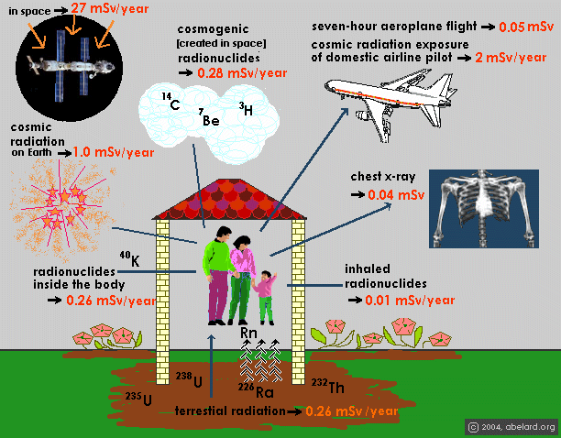
Internal radiation sources
All earthly materials that are the building-blocks contain a radioactive component. As humans, plants, and animals consume food, air, and water, radioisotopes build up within the organism. Some radionuclides, like potassium-40, emit a high-energy gamma ray that can be measured by sensitive electronic radiation measurement systems. These internal radiation sources contribute to an individual's total radiation dose from natural background radiation.

Radon
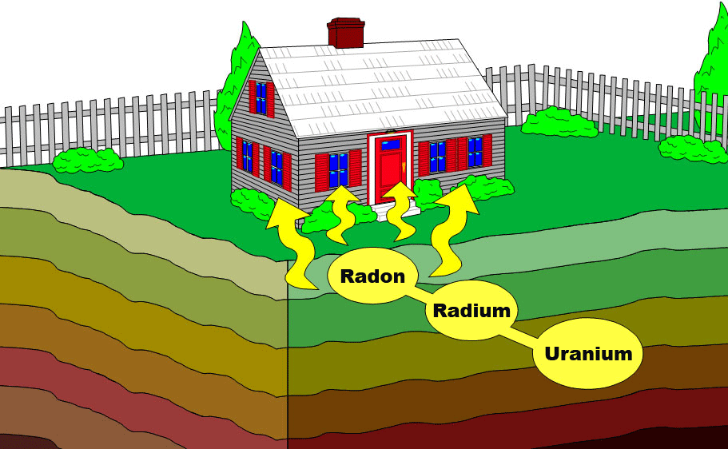
An important source of natural radiation is radon gas, which seeps continuously from bedrock but can, because of its high density, accumulate in poorly ventilated houses.
Radon-222 is a gas produced by the decay of radium-226. Both are a part of the natural uranium decay chain. Uranium is found in soil throughout the world in varying concentrations. Among non-smokers, radon is the largest cause of lung cancer.

Question 4
Types of ionizing radiation

Ionizing radiation is categorized by the nature of the particles or electromagnetic waves that create the ionizing effect. These types have different ionization mechanisms, and may be grouped as directly or indirectly ionizing.
Directly ionizing
Alpha particles consist of two protons and two neutrons bound together into a particle identical to a helium nucleus ⁴ ₂He.
Alpha particle emissions are generally produced in the process of alpha decay, but may also be produced in other ways. Alpha particles are named after the first letter in the Greek alphabet, α. The symbol for the alpha particle is α or α²⁺.
Alpha particles are a highly ionizing form of particle radiation. They can be stopped by a few centimeters of air, or by the skin. Alpha particles (helium nuclei ) are the least penetrating. Even very energetic alpha particles can be stopped by a single sheet of paper.
Beta particles are high-energy, high-speed electrons or positrons emitted by certain types of radioactive nuclei, such as potassium-40. The production of beta particles is termed beta decay. They are designated by the Greek letter beta (β). Of the three common types of radiation given off by radioactive materials, alpha, beta and gamma, beta has the medium penetrating power and the medium ionising power. Although the beta particles given off by different radioactive materials vary in energy, most beta particles can be stopped by a few millimeters of aluminium.
Indirectly ionizing
Indirect ionizing radiation is electrically neutral and therefore does not interact strongly with matter.
An example of indirectly ionizing radiation is gamma radiation, X-rays and neutron radiation.
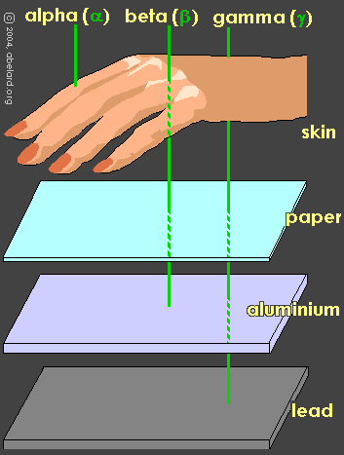
Gamma radiation, also known as gamma rays, and denoted by the Greek letter γ, refers to electromagnetic radiation of an extremely high frequency and therefore consists of high-energy photons.
Natural sources of gamma rays on Earth include gamma decay from naturally occurring radioisotopes, and secondary radiation from atmospheric interactions with cosmic ray particles.
When a gamma ray passes through matter, the probability for absorption is proportional to the thickness of the layer and the density of the material. Gamma rays are better absorbed by materials with high atomic numbers and high density, the example of such material is lead.
Neutron radiation is a kind of ionizing radiation which consists of free neutrons. A result of nuclear fission or nuclear fusion consists of the release of free neutrons from atoms, and these free neutrons react with nuclei of other atoms to form new isotopes, which, in turn, may produce radiation.
The neutrons in nuclear reactors are generally categorized as slow (thermal) neutrons or fast neutrons depending on their energy.
Neutrons readily pass through most material, but interact enough to cause biological damage. The most effective shielding materials are hydrocarbons, eg polyethylene, paraffin wax or water. Concrete (where a considerable amount of water molecules are chemically bound to the cement) and gravel are used as a cheap and effective shielding due to their combined shielding of both gamma rays and neutrons.

Question 5
Factors causing ionizing radiation effects on the human body

Factors causing ionizing radiation effects on the human body.
1. The amount of absorbed dose of radiation.
2. The duration and the granularity of exposure.
3. The volume (area) of irradiated tissues.
4. The radiosensitivity of tissues and organs.
"Bergane Tribondeau Rule ": radiation sensitivity of tissues is directly proportional to proliferative activity and inversely proportional to the degree of differentiation of its cells.
5. Type of exposure (external or internal)
6. Individual characteristics of the human body (sex, age, state of health, functional state of the human body during exposure, etc.)

Question 6
The biological effects of radiation on human body. "Deterministic effects" and "Stochastic effects"

The radiation effects are generally divided into two categories: "Deterministic effects" and "Stochastic effects".
Acute health effects such as skin burns or acute radiation syndrome can occur when doses of radiation exceed certain levels
Beyond certain thresholds, radiation can impair the functioning of tissues and/or organs and can produce acute effects such as skin redness, hair loss, radiation burns, or acute radiation syndrome. These effects are more severe at higher doses and higher dose rates. For instance, the dose threshold for acute radiation syndrome is about 1 Sv (1000 mSv).
Deterministic (not stochastic) threshold effects - immediate somatic effects occurring in hours, days, months after exposure (Example: acute radiation reactions, acute and chronic radiation syndrome, radiation burns).
Severity of deterministic effects depends on dose. However, thresholds exist, only above which the effects will occur.
Characteristics of deterministic effects:
• Damage depends on absorbed dose
• Threshold exists
Stochastic (probabilistic) thresholdless effects – effects that are independent of the absorbed dose. The stochastic effects may or may not occur. There is no threshold and the probability of having the effects is proportional to the dose absorbed.
Characteristics of stochastic effects:
• Severity is independent of absorbed dose
• Threshold does not exist
• Probability of occurrence depends on absorbed dose
Example: radiation induced cancer, genetic effect
If the dose is low or delivered over a long period of time (low dose rate), there is greater likelihood for damaged cells to successfully repair themselves. However, long-term effects may still occur if the cell damage is repaired but incorporates errors, transforming an irradiated cell that still retains its capacity for cell division. This transformation may lead to cancer after years or even decades have passed. Effects of this type will not always occur, but their likelihood is proportional to the radiation dose. This risk is higher for children and adolescents, as they are significantly more sensitive to radiation exposure than adults.
Epidemiological studies on populations exposed to radiation (for example atomic bomb survivors or radiotherapy patients) showed a significant increase of cancer risk at doses above 100 mSv.

Question 7
Acute radiation syndrome

Acute radiation syndrome (ARS), also known as radiation poisoning, radiation sickness or radiation toxicity, is a collection of effects which present within 24 hours of exposure to high amounts of ionizing radiation. The radiation causes cellular degradation due to damage to DNA and other key molecular structures within the cells in various tissues; this destruction, particularly as it affects ability of cells to divide normally, in turn causes the symptoms. The symptoms can begin within one or two hours and may last for several months.
The onset and type of symptoms depends on the radiation exposure. Relatively smaller doses result in gastrointestinal effects, such as nausea and vomiting, and symptoms related to falling blood values, and predisposition to infection and bleeding. Relatively larger doses can result in neurological effects and rapid death. Treatment of acute radiation syndrome is generally supportive with blood transfusions and antibiotics; in extreme cases bone marrow transfusion is required.
Similar symptoms may appear months to years after exposure as chronic radiation syndrome when the dose rate is too low to cause the acute form.
Classically acute radiation syndrome is divided into three main presentations: hematopoietic, gastrointestinal and neurological/vascular. These symptoms may or may not be preceded by a prodrome. The speed of onset of symptoms is related to radiation exposure, delay in symptom onset becomes more shorter in case of dose increasing.
The prodrome (early symptoms) of ARS typically includes nausea and vomiting, headaches, fatigue, fever and short period of skin reddening. These symptoms may occur at radiation doses as low as 0.35 Gy. These symptoms are common to many illnesses and may not, by themselves, indicate acute radiation sickness.
Hematopoietic. This syndrome is marked by a drop in the number of blood cells, called aplastic anemia. This may result in infections due to a low amount of white blood cells, bleeding due to a lack of platelets, and anemia due to few red blood cells in the circulation. These changes can be detected by blood tests after receiving a whole-body acute dose as low as 0.25 Gy, though they might never be felt by the patient if the dose is below 1 Gy.
Gastrointestinal. This syndrome often follows absorbed doses of 6–30 Gy. The signs and symptoms of this form of radiation injury include nausea, vomiting, loss of appetite, and abdominal pain. Without exotic treatment such as bone marrow transplant, death with this dose is common. The death is generally more due to infection than gastrointestinal dysfunction.
Neurovascular. This syndrome typically occurs at absorbed doses greater than 30 Gy. It presents with neurological symptoms such as dizziness, headache, or decreased level of consciousness. It is invariably fatal.

Each student writes a conclusion for each of the 2 tasks in his notebook takes a photo and sends it for check!

Case 1
37 years man was involved in the liquidation of the Chernobyl accident. He had weakness, nausea, vomiting within 2 hours after work. The received external radiation dose was 15 Gy. The man was taken to a hospital.
A grave condition, abdominal pain, pain in muscles and joints, headache, skin reddening, purpura. Pulse rate was 60 per one minute, arterial pressure was 80/50 mm Hg, body temperature was 38.4° C.
The patient's condition improved after 3 days, but the general condition of the patient deteriorated 2 days later, body temperature increased to 39° C, loss of appetite, severe diarrhea, decrease level of consciousness. Blood tests revealed erythrocytes 2,5*10¹²/l,, HB 80 g/l, reticulocytes 0,2 %, leukocytes 1,5*10⁹/l, lymphocytes 0,2*10⁹/l, platelets 9*10⁹/l, ESR 50 mm/h. Bone marrow analysis: the number of proliferating erythroblasts decreased by 60%.
Intestinal bleeding and peritonitis appeared by the end of the week. Patient slipped into a coma, death occurred after 10 days of the disease.

Write a diagnosis of this disease.

Case 2
A soldier was at the epicenter of a nuclear explosion. 30 minutes after the explosion he had a general weakness, dizziness, nausea, repeated vomiting. He was taken to a hospital. He was in the state of moderate severity, torpid, with deferred reaction, pulse was 100 beats / min, blood pressure - 110/60 mm Hg. Art, the body temperature of 38,2°С.
On the 15th day after irradiation patient's condition deteriorated. He had a weakness, chills, bleeding gums, bleeding in the skin, cough with discharge of a moderate amount of purulent sputum, shortness of breath, chest pain, aggravated by deep breathing and coughing, diarrhea, face hyperemic. He was in the state of moderate severity, torpid, with deferred reaction. Pulse was 120 beats / min, rhythmic, weak filling. Heart sounds were muffled. Blood pressure 100/60 mm Hg. Art. The respiratory rate per minute 24. Breathing was hard with wet small- and medium bubbling rale. The abdomen was soft, painful in the course of the colon. The body temperature of 39,8 ° C. In a blood test: erythrocytes 3,5 × 1012 / L 100 g Hb / l, reticulocytes single smear, leukocytes 0,5 × 109 / L Lymphocytes 0,2 × 109 / L Platelets 20 × 109 / l ESR 58 mm / hr. Myelogram: bone marrow depletion, reducing the number of proliferating erythroblasts 30%. X-rays of the chest: increased lung marking. Infiltration in the projection of the lower lobe on both sides.
Write a diagnosis of this disease.

